**Debate lab**

**Biology 1520 Lab**

**Pre-lab assignment**

Create a **map or diagram** that includes the following scientific terminology related to understanding genetically modified organisms. This should be completed by hand, in your lab notebook; you’ll turn one copy to T-Square (you can diagram it electronically, or hand write it and upload a scan or picture) before your lab and keep one copy in your lab notebook. Your map or diagram must contain the following:

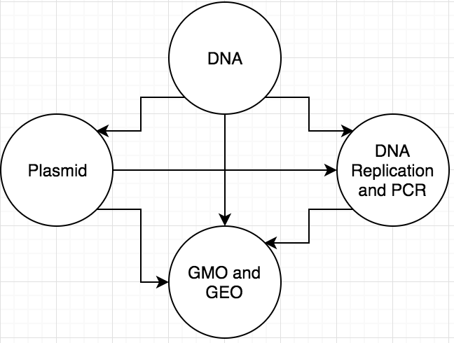

DNA Replication, PCR, and Plasmids are used to create GMO’s and DNA is the basis for DNA Replication, PCR, and Plasmids, and DNA Replication and PCR is the replication of DNA.

**Scientific terminology to include:**

Genetically modified organism (GMO) or genetically engineered organism (GEO) – organisms where

the genetic information is modified to create something that would not occur naturally (Freeman et al. 2013)

DNA - deoxyribonucleic acid and is the genetic blueprint in almost all organisms (Freeman et al. 2013)

DNA replication and PCR – when DNA undergoes mitosis multiple times to create similar copies and specifically PCR is the industrialized technique to create many copies of DNA (Freeman et al. 2013)

Plasmid – linear or circular strand of DNA that can self replicate (Freeman et al. 2013)

References:

Freeman, Quillin, & Allison 2013. Biological Science, 5th edition. Pearson Benjamin Cummings.

**How this assignment is graded (10 pt):**

1 point per correct definition in your own words, with connections to other terms (5 points total)

1 point per correct reference (5 points total)